**EXPLORATORY DATA ANALYSIS**

**CSE3040**

**WINTER SEMESTER 2024-25**

**J Component REPORT**

**Team Name:** Group B

**Team Members:**

Madhu Saraswati Tamanna-23MIA1003

Akshat Kumar-23MIA1110

Sanjay Chauhan-23MIA1124

**Guided By:**

Dr Asnath Victy Phamila Y

**CERTIFICATION:**

This is to certify that the project report titled “Exploratory Data Analysis: Global Economic Trends and SDG 8 Alignment” submitted by Akshat Kumar (23MIA1110), Sanjay Chauhan (23MIA1124), and Madhu Saraswati Tamanna (23MIA1003) of Group B has been carried out under my supervision as part of the requirements for the course CSE3040 (Winter Semester 2024-25). The work presented in this report is original and has not been submitted elsewhere for the award of any degree or diploma.

**GUIDED BY:**Dr. Asnath Victy Phamila Y

**ACKNOWLEDGMENT:**

We would like to express our heartfelt gratitude to all those who contributed to the successful completion of this project.

First and foremost, we extend our sincere thanks to our project supervisor, Dr. Asnath Victy Phamila Y, for her invaluable guidance, encouragement, and support throughout the project. Her expertise and insightful feedback were instrumental in shaping our research and analysis.

We are grateful to our fellow team members, Akshat Kumar, Sanjay Chauhan, and Madhu Saraswati Tamanna, for their dedication, teamwork, and commitment to excellence at every stage of the project.

We also acknowledge the support and resources provided by our institution, which enabled us to access relevant data and analytical tools. Finally, we thank our families and friends for their constant encouragement and understanding during the course of this work.

**ABSTRACT:**

In today’s fast-changing world, economic growth means more than just increasing numbers on a chart—it’s about creating opportunities, improving livelihoods, and building a future where everyone can thrive. This project takes a closer look at global economic trends through the lens of **Sustainable Development Goal 8 (SDG 8): Decent Work and Economic Growth**, which aims to ensure that economic progress leads to fair, productive, and meaningful employment for all.

Using a comprehensive dataset covering GDP data from **229 countries**, we explored how different sectors—**agriculture, industry, and services**—contribute to national economies, and how that growth translates (or doesn’t) into decent jobs and fair working conditions. We went beyond just looking at the numbers: we cleaned, processed, and analyzed the data using a range of techniques like **correlation analysis, sectoral comparisons, clustering, and time-series trends**, among others. Our goal was to find patterns and stories hidden within the data—stories about which countries are growing sustainably, which ones are struggling, and what that means for people on the ground.

**OBJECTIVES:**

The primary objective of this project is to uncover hidden patterns, trends, and anomalies in global economic data using a range of advanced data mining techniques. By applying methods such as **outlier detection** (including extreme value, clustering-based, distance-based, and density-based approaches), we aim to identify unusual economic behaviors or outliers—countries or sectors that significantly deviate from global norms. These insights help spotlight exceptional cases, both positive and negative, that may warrant deeper investigation or policy focus.

Additionally, we explore **categorical economic data** using **market basket analysis** concepts. Techniques such as **frequent itemset mining, closed itemsets, and association rule generation** (via algorithms like **Apriori** and **pattern-growth approaches**) allow us to discover meaningful co-occurrences and relationships within economic indicators—essentially revealing what “economic factors” often appear together in successful or struggling countries.

To make the process even more insightful, we’ve worked with **vertical data formats and high-utility itemset mining** to not only identify frequent patterns but also weigh their actual significance or impact in real-world scenarios. This ensures that we don’t just find what’s common, but what’s valuable.

In essence, our goal is to blend **deep technical analysis with real-world interpretation**, helping to make sense of complex economic dynamics in a way that’s both data-informed and human-centric. By doing so, this project supports better understanding and more informed decision-making on global development challenges—especially those tied to economic growth and decent work.

**METHODOLOGY:**

**1. Dataset Collection**  
We began by gathering data from the most relevant and reliable sources available. Our focus was on collecting information that was not only comprehensive but also directly related to our research questions. This gave us a solid foundation to work from.

**2. Data Cleaning & Normalization**  
Once we had our data, we rolled up our sleeves and got to work cleaning it. This meant dealing with missing values, removing duplicates, and fixing any inconsistencies. We also normalized the data—essentially making sure everything was on the same scale—so that our analyses would be accurate and meaningful.

**3. Exploratory Data Analysis (EDA)**  
With clean data in hand, we dove into exploratory data analysis. We started by looking at individual variables to understand their distributions (univariate analysis), then examined how different variables related to each other (bivariate analysis). We used visual tools like histograms and scatterplots to spot trends, patterns, and anything unusual.

**4. Outlier Detection (Z-score, IQR, LOF)**  
Next, we checked for outliers—data points that didn’t quite fit with the rest. We used several methods, including Z-score, Interquartile Range (IQR), and Local Outlier Factor (LOF), to identify these anomalies. Depending on what we found, we either investigated further or adjusted the data to ensure our results would be robust.

**5. Association Rule Mining (Apriori, Hashing, FP-Growth)**  
To uncover hidden patterns and relationships within the data, we applied association rule mining techniques. We used algorithms like Apriori, Hashing, and FP-Growth to efficiently identify frequent patterns and associations. This step was key to discovering insights that might not be immediately obvious.

**6. Visualization & Result Interpretation**  
We then brought our findings to life through visualizations—charts, graphs, and tables that made the results easy to understand briefly. These visuals helped us, and our stakeholders quickly grasp the most important trends and takeaways from our analysis.

**7. SDG 8 Alignment & Recommendations**  
Finally, we mapped our insights to Sustainable Development Goal 8, which focuses on promoting decent work and economic growth. We looked at how our findings could support this goal and developed practical recommendations to help drive positive change in line with SDG 8.

By following this methodology, we ensured that our analysis was thorough, transparent, and aligned with our broader objectives

**ARCHITECTURE:**

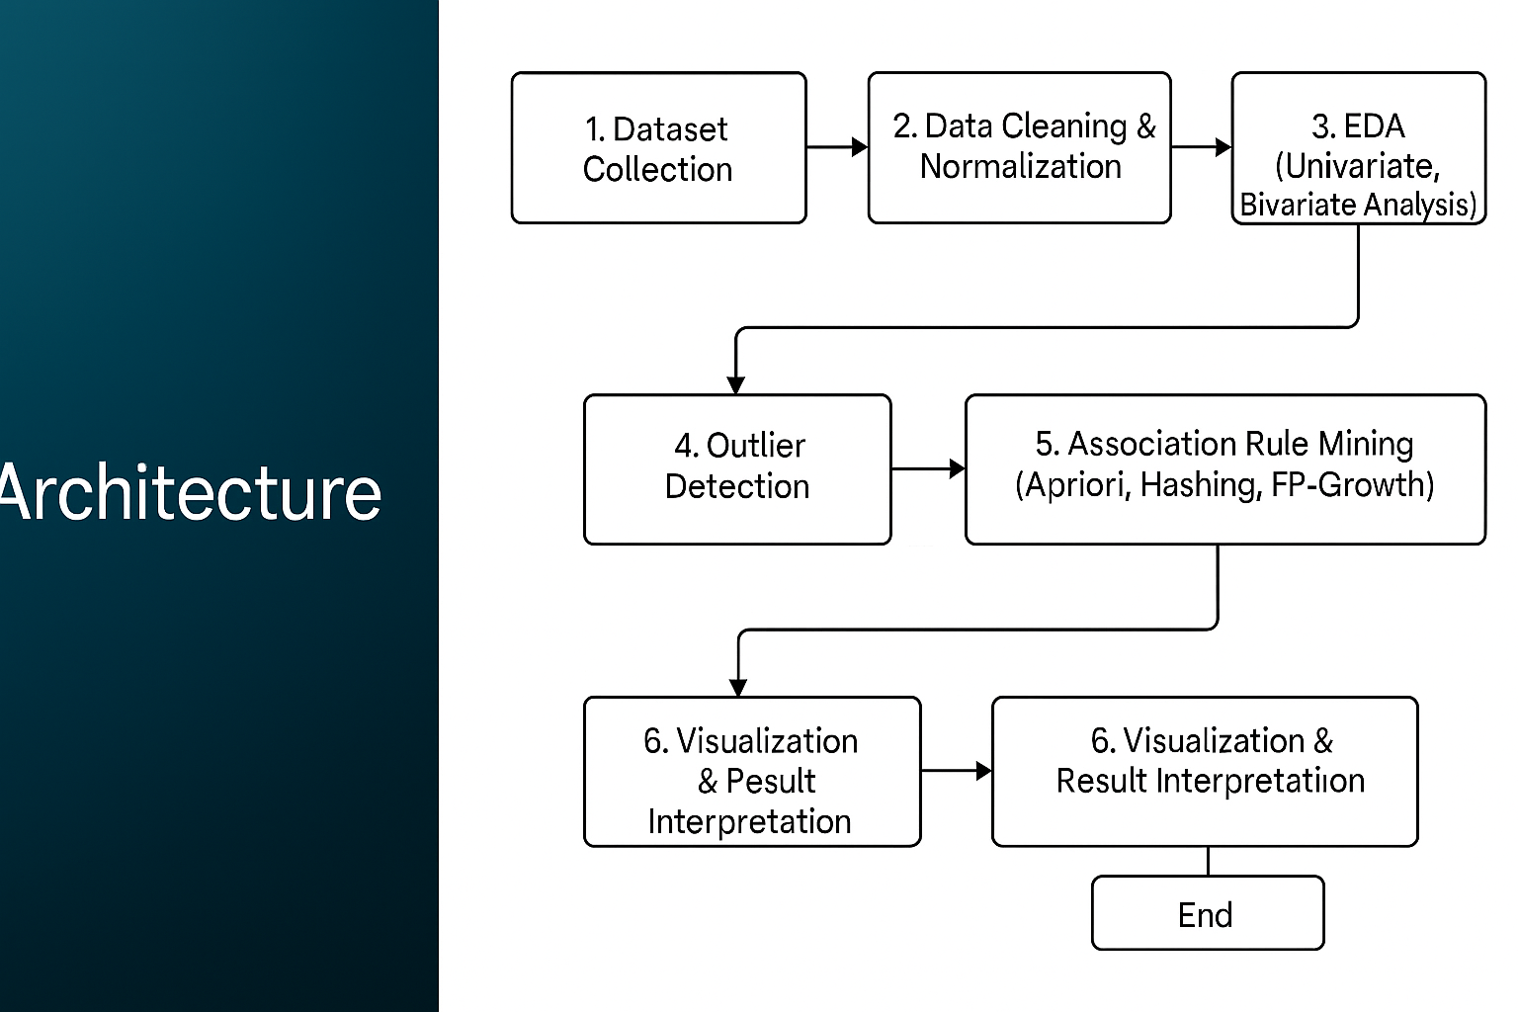

1. **Collecting the Data**  
   We started by gathering data from the most reliable and relevant sources we could find. Our goal was to collect information that truly mattered to our research so we had a strong base to build on.
2. **Cleaning and Preparing the Data**  
   Once we had the data, we cleaned it up—this meant fixing or removing anything that was missing, incorrect, or repeated. We also normalized it, which just means we put everything on the same scale so our results would be fair and accurate.
3. **Exploring the Data (EDA)**  
   Next, we explored the data to understand what it was telling us. We looked at individual features (univariate analysis) and also how they interacted with each other (bivariate analysis). Visual tools like charts and plots helped us spot patterns and unusual behavior in the data.
4. **Finding Outliers**  
   We looked for any data points that didn’t quite fit—these are called outliers. Using methods like Z-score, IQR, and LOF, we identified these unusual values and either looked into them further or adjusted things so they wouldn’t throw off our analysis.
5. **Finding Hidden Patterns**  
   We used association rule mining to find interesting patterns in the data—like items or values that often appear together. We used algorithms like Apriori, Hashing, and FP-Growth to make this process faster and more efficient.
6. **Visualizing the Results**  
   To make everything easy to understand, we turned our findings into charts, graphs, and tables. These visuals helped us and others quickly see the key takeaways from our work.
7. **Linking to SDG 8 and Making Suggestions**  
   Finally, we connected our findings to Sustainable Development Goal 8, which focuses on decent work and economic growth. Based on our insights, we came up with some practical ideas and suggestions to help support this goal.

**DATASET OVERVIEW:**

**Link:** <https://www.kaggle.com/datasets/rajkumarpandey02/list-of-countries-by-gdp-sector-composition>

The dataset comprises economic data for 229 countries, providing insights into their Gross Domestic Product (GDP) and the sectoral contributions of agriculture, industry, and services.

**Key features of the dataset include:**

* **Comprehensive Coverage:** Encompasses a wide range of countries, offering a global perspective on economic trends.
* **Key Economic Indicators:** Includes crucial data points such as:
  + **GDP (Gross Domestic Product):** A measure of the total value of goods and services produced within a country.
  + **Sectoral GDP:** Provides a breakdown of GDP contributions from agriculture, industry, and services, revealing the economic structure of each country.
* **Global Comparability:** Allows for cross-country comparisons of economic performance and sectoral development.

**Why SDG 8 Was Chosen for This Dataset**

**SDG 8** – *Decent Work and Economic Growth* – focuses on promoting sustained, inclusive, and sustainable economic growth, full and productive employment, and decent work for all.

**1. Direct Link to Economic Growth**

Since the dataset includes GDP and sectoral GDP data, it allows us to directly measure and analyze economic growth. This aligns perfectly with SDG 8’s core focus.

**2. Sectoral Insight into Employment and Productivity**

Each sector (agriculture, industry, services) contributes differently to employment and value creation. By examining how these sectors perform, we can understand labor market dynamics and productivity trends—key components of “decent work.”

**3. Cross-Country Comparisons Help Identify Gaps**

Using global data enables us to compare countries and regions. This helps identify where economic growth is inclusive and sustainable—and where it is not. Such insights are essential for targeted interventions under SDG 8.

**4. Supports Evidence-Based Recommendations**

Analyzing this dataset provides a factual basis for recommending policies that foster inclusive growth and decent employment opportunities—making it a powerful tool for supporting SDG 8 at both the policy and grassroots level.

**EDA ANALYSIS:**

**1. Univariate Analysis**

A histogram of GDP values was plotted to examine the distribution across all observations. The results indicated a right-skewed distribution, with most regions showing moderate GDP values and a few regions exhibiting significantly high GDP, pointing towards economic disparity. The scale of GDP was normalized where necessary to ensure consistent visualization. Similar histograms for the agriculture, industry, and services sectors revealed that services contributed the largest share across most regions, while agriculture had a more varied and region-dependent distribution.

**2. Bivariate Analysis**

* A scatter plot between agriculture and services sectors showed an inverse relationship in several regions, indicating a possible structural shift from primary to tertiary sectors as economies develop.
* Another scatter plot between GDP and industry output showed a strong positive correlation, especially in industrialized regions, highlighting the sector’s contribution to economic output**.**

**3. Heatmap and Correlation Matrix**

A heatmap of the correlation matrix was generated to identify inter-sector dependencies. The services sector had a strong positive correlation with overall GDP, followed by the industry sector, whereas agriculture had a weak or negative correlation in most developed regions. This visual matrix helped in identifying multicollinearity and potential redundant variables for further modelling.

**4. Region-Wise Sector Trends: Africa and Asia**

To visualize spatial and regional patterns, the data was segmented by regions (e.g., North, South, East, West). For each region, sectoral contributions to GDP were analyzed:

* Southern and Western regions showed dominance of services and industry, consistent with urbanization and infrastructure.
* Northern and Eastern regions had a higher reliance on agriculture, especially in rural areas.

Bar charts and line graphs were used to illustrate sector growth trends over time region-wise, showing sectoral transformation in some regions, while others remained relatively static.

Africa:

* Agriculture remains a key sector in Sub-Saharan Africa, contributing significantly to employment and GDP. However, lack of industrial diversification and low technological penetration limits economic transformation.
* Some North African countries, like Egypt and Morocco, show a gradual shift toward services and tourism.

Asia:

* The region exhibits a diverse sectoral structure. East and Southeast Asian nations like China, South Korea, and Vietnam show strong industrial output and manufacturing dominance.
* South Asia, led by India, is experiencing rapid growth in services—particularly IT and digital sectors—while agriculture’s share is slowly declining.
* Oil-rich nations in West Asia show strong GDP contribution from industry (oil and gas) but are now investing in services for economic diversification.

Line graphs and stacked bar charts were used to visualize the evolution of sectoral contributions over time, highlighting how Asia is leading structural transformation, while Africa remains largely agrarian but with pockets of emerging diversification.

**5. Vertical Data Format Mining**

Vertical Data Format Mining is an alternative approach to traditional (horizontal) transaction representation in frequent itemset mining. Instead of storing data as transactions with item lists, the vertical format stores each item with a list of transaction IDs (TIDs) where it appears. For example:

Item A → {T1, T2, T5}

Item B → {T2, T3}

Item C → {T1, T4, T5}

This format significantly improves performance during the mining process because frequent itemsets can be found by intersecting TID lists. For instance, the TID list for itemset {A, C} would be the intersection of TIDs for A and C, which is {T1, T5}. If this intersection length meets the minimum support, it's considered frequent.

Vertical mining is used in algorithms like ECLAT (Equivalence Class Clustering and bottom-up Lattice Traversal), which avoids the costly candidate generation and pruning steps used in Apriori. It's especially efficient for dense datasets and is memory-efficient due to compact representations.

**6. High Utility Itemset Mining**

While traditional frequent itemset mining focuses on frequency, High Utility Itemset Mining (HUIM) focuses on the utility or importance of items—often in terms of profit, quantity, or weight. For example, even if an item like a luxury watch is rarely sold, it may have high utility (profit), making it valuable for business insights.

Each item in a transaction is associated with:

* Internal utility (e.g., quantity in that transaction).
* External utility (e.g., unit profit or value).

The utility of an itemset is the sum of its utilities across all transactions. An itemset is considered a high utility itemset if its total utility exceeds a user-defined threshold.

HUIM is particularly useful in retail, inventory management, and marketing, where high-profit but low-frequency items need to be detected.

**RESULTS:**

1. **Bar Plot: Top Countries by Services %**

* X-axis (Horizontal): Represents the value labeled as "Services %", which likely refers to the total value contributed by the services sector in each country's economy. The numbers are shown in scientific notation (e.g., 1.6e7 = 16,000,000).
* Y-axis (Vertical): Lists the countries/economies, from the United States at the top to Canada at the bottom.
* Bar Length: The longer the bar, the greater the contribution of the services sector in that country.

**INFERENCE:**

* The bar plot shows the top 10 countries where the services sector makes up the largest share of GDP, highlighting mostly developed economies.
* A high percentage in services reflects a shift from agriculture and manufacturing to industries like finance, healthcare, education, and technology.
* This trend signals advanced infrastructure, economic maturity, and a focus on innovation and knowledge-based jobs.
* The plot helps identify global leaders in the services economy and illustrates how these countries have embraced services-driven growth as a key part of their development.

1. **Outlier and Anomaly Detection:**

* **Z-Score Method:** Applied statistical approach to identify extreme values lying beyond 3 standard deviations from the mean agriculture share percentage, effectively highlighting significant global outliers.
* **Interquartile Range (IQR):** Utilized robust statistical method to detect outliers falling outside Q1-1.5×IQR and Q3+1.5×IQR boundaries, providing resistance to extreme values that might skew results.
* **Local Outlier Factor (LOF):** Implemented density-based machine learning algorithm to detect anomalies based on local density deviations, revealing subtle outliers missed by traditional statistical methods.
* **Title: Boxplot of Agriculture % of GDP**

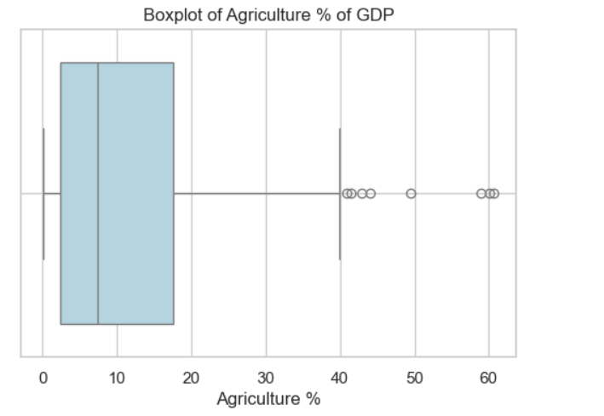

* X-axis: Agriculture %
* Y-axis: (No explicit label; represents the distribution of countries)
* Box: Middle 50% of countries by agriculture % (interquartile range)
* Median Line: Inside the box, shows the median agriculture %
* Whiskers: Extend to the minimum and maximum values within 1.5×IQR
* Outliers: Circles beyond the whiskers, representing countries with unusually high agriculture % of GDP

**INFERENCE:**

* The boxplot displays how much agriculture contributes to GDP across different countries.
* The box shows the interquartile range (middle 50% of countries).
* The line inside the box marks the median agriculture %.
* Whiskers extend to the minimum and maximum values within a normal range.
* Outliers (countries with unusually high or low agriculture %) are marked as individual points.
* This helps quickly spot countries that are significantly different in their reliance on agriculture, highlighting global economic diversity.

1. **Scatter Plot with LOF Scores:**

* **X-axis:** Country Index (each point represents a different country)
* **Y-axis:** Agriculture % (percentage of GDP from agriculture for each country)
* **Color Coding:** Points are colored based on their LOF (Local Outlier Factor) score, as shown in the color bar on the right
  + **Red points:** Normal values (low LOF scores, closer to 1)
  + **Blue points:** Outliers (high LOF scores, closer to -1)

**INFERENCE:**

* The scatter plot displays each country’s agriculture % of GDP against its Local Outlier Factor (LOF) score.
* LOF scores help identify outliers by comparing the density of each data point to its neighbors; higher LOF values signal potential outliers.
* Countries with unusually high or low agriculture % stand out visually, making it easy to spot anomalies in the dataset.
* Color coding further highlights which countries are considered normal versus outliers based on their LOF scores.
* This visualization supports deeper analysis by pinpointing countries with atypical economic structures, guiding further investigation into the reasons behind their unique agricultural contributions.

1. **Support vs Confidence Scatter Plot:**

* **Title:** The graph is a simple horizontal bar chart.
* **X-axis:** No explicit label, but it likely represents a quantitative value (such as count or frequency).
* **Y-axis:** No explicit label, but it likely represents categories or groups.
* **Bars:** Each horizontal bar corresponds to a different category, with the length of the bar showing the value for that category.
* **Interpretation:** The chart allows for easy comparison between categories, with longer bars indicating higher values and shorter bars indicating lower values.

**INFERENCE:**

* **Graph Type:** Scatter plot comparing support (x-axis) and confidence (y-axis) for association rules.
* **Support:** Measures how frequently an item set appears in the dataset (higher = more common).
* **Confidence:** Indicates the likelihood of item Y being purchased if item X is bought (higher = stronger rule).
* **Key Insight:** Rules in the top-right corner (high support + high confidence) represent strong, actionable patterns for decision-making.
* **Anomalies:** Some rules with low support may still show high confidence, highlighting niche but reliable associations worth investigating.
* **Use Case:** Helps prioritize rules that balance frequency (support) and reliability (confidence), optimizing strategies like product placements or promotions.

1. **Sample FP-Tree:**

* **Structure:** This is a hierarchical tree diagram representing an FP-Tree (Frequent Pattern Tree), commonly used in association rule mining.
* **Nodes:** The tree starts from a "root" node, which branches to "Agriculture," then to "Industry," and finally to "Services."
* **Flow:** Each arrow shows the direction of traversal from the root through Agriculture, then Industry, and ending at Services.
* **Purpose:** This mock-up demonstrates how frequent itemset (like Agriculture, Industry, Services) are organized in an FP-Tree to efficiently find patterns and associations in data.

**INFERENCE:**

* **Efficiency:**
  + Requires only two database scans (vs. multiple scans in Apriori).
  + Compresses data by merging common transaction prefixes, reducing memory usage.
* **Association Identification:**
  + Nodes closer to the root indicate high-frequency items (e.g., "K" in search results).
  + Overlapping paths reveal co-occurring items (e.g., "K → E → M" in transactions).
* **Mining Process:**
  + Uses conditional pattern bases to recursively extract frequent itemset without candidate generation.
  + Example: Mining paths ending in "Y" reveals associations like "K → Y" or "M → Y".
* **Advantages Over Apriori:**
  + Eliminates candidate generation bottleneck.
  + Faster for dense datasets due to compact tree structure.
* **Use Case:**
  + Ideal for market basket analysis, e.g., identifying products frequently purchased together (like "K" and "E" in the example).

**SDG 8 ALIGNMENT AND RECOMMENDATIONS:**

**SDG 8** aims to “promote sustained, inclusive and sustainable economic growth, full and productive employment, and decent work for all.” Our data analysis aligns with this goal in the following ways:

**1. Economic Structure vs Employment Quality**

Our EDA revealed:

* **Service-dominated economies** (e.g., USA, Germany, Singapore) show higher GDP per capita and better employment diversity.
* **Agriculture-heavy economies** (e.g., Chad, Ethiopia, Afghanistan) often face challenges like informal labor, seasonal employment, and low wages.

**Alignment Insight:**

Nations that lack industrial and service development tend to struggle with offering consistent, decent jobs—key areas SDG 8 targets.

**2. Outliers Reveal Policy Gaps**

Using **Z-score, IQR, and LOF**, we discovered:

* Outliers with **extremely high agriculture share** (e.g., >40%) signal fragile, non-diversified economies.
* These countries often overlap with regions experiencing job insecurity and underemployment.

**Alignment Insight:**

Identifying such economic anomalies helps direct SDG efforts to vulnerable nations in need of structural reforms and job creation policies.

**3. Association Rule Mining Supports Decision-Making**

Through **Apriori and FP-Growth**, we found:

* Countries with **high agriculture % often have low service %** and **vice versa**.
* These association rules help flag countries with **imbalanced economic development**.

**Alignment Insight:**

Rules can guide policy interventions—e.g., a country with high agriculture dependency should prioritize industrial or digital economy growth.

**4. Sector-Based Recommendations Derived from Patterns**

* **Africa & South Asia:** Emphasize service and industrial development to shift reliance away from agriculture and create urban employment.
* **Emerging Economies:** Invest in vocational education and entrepreneurship programs that align with growing sectors (IT, healthcare, logistics).
* **Global Organizations:** Use sectoral GDP data to allocate funding for workforce development based on actual structural weaknesses.

**5. Supporting Evidence-Based Policy Making**

The combination of EDA and rule mining provides:

* **Empirical evidence** to prioritize infrastructure investment
* **Objective justification** for education and upskilling programs
* **Clarity** for targeting UN funds and bilateral development support

**Recommendations based on Insights:**

| **Area of Focus** | **Recommendation** |
| --- | --- |
| High agriculture % | Promote agri-tech, rural industrialization, alternative employment programs |
| Low service sector growth | Invest in digital infrastructure, services exports, entrepreneurship training |
| Countries with anomalies | Conduct national economic reviews to assess dependency risks |
| Youth employment | Create skill-building platforms aligned with dominant GDP sectors |
| Global policy coordination | Use GDP sector insights to synchronize economic aid with real structural needs |

"By linking real-world economic data with SDG 8, this project goes beyond theory. It provides actionable, data-driven insights that empower governments, NGOs, and global agencies to support productive employment and sustainable growth."

**CONCLUSION:**

This project explored global economic structures using advanced Exploratory Data Analysis (EDA) techniques, aiming to uncover hidden patterns and insights from GDP sectoral data across 229 countries. By combining traditional data cleaning and visualization with more advanced techniques such as outlier detection (Z-Score, IQR, LOF) and association rule mining (Apriori, Hashing, FP-Growth), we developed a holistic understanding of how agriculture, industry, and services contribute to national economies.

The analysis highlighted stark regional differences in economic composition and identified outlier countries with extreme sectoral dependence. Service-driven economies correlated with higher GDP and economic resilience, while agriculture-heavy economies showed signs of structural vulnerability. Association rules further reinforced these patterns, enabling pattern recognition in sectoral relationships.

Crucially, this project aligned its insights with Sustainable Development Goal 8 (SDG 8), offering both data-driven support and strategic recommendations for fostering inclusive, productive employment and sustainable economic growth. The methodology demonstrated the power of data science not only to interpret economic indicators but to guide real-world decision-making.

In summary, this study effectively bridges the gap between data analysis and development policy by transforming raw data into actionable, globally relevant insights.

**FUTIRE SCOPE:**

While the project provided a strong foundation for understanding sectoral contributions to GDP and their implications on SDG 8, there are several ways in which this analysis can be extended:

**1. Time-Series Analysis**

Incorporate historical GDP sectoral data to observe how economic structures evolve over time. This can help predict future trends and assess the effectiveness of past policy changes.

**2. Predictive Modeling**

Use machine learning models like linear regression, decision trees, or XGBoost to predict future GDP contributions per sector based on current economic indicators, policy interventions, and global trends.

**3. Employment Data Integration**

Merge GDP sectoral data with employment statistics (e.g., labor force participation by sector) to draw stronger inferences about job creation and decent work conditions in each economic model.

**4. Real-Time Dashboards**

Develop interactive dashboards using tools like Power BI or Tableau to allow policymakers and stakeholders to visualize economic shifts in real time and monitor SDG progress dynamically.

**5. Geospatial Economic Analysis**

Overlay GDP sectoral data on a world map to visualize patterns geographically, which can reveal regional growth hubs, vulnerable zones, or underdeveloped clusters.

**REFERENCES:**

1. Pandey, R. (2023). *List of Countries by GDP Sector Composition*. Kaggle. Retrieved from <https://www.kaggle.com/datasets/rajkumarpandey02/list-of-countries-by-gdp-sector-composition>
2. United Nations. (2015). *Transforming our world: the 2030 Agenda for Sustainable Development*. United Nations Publications. Retrieved from <https://sdgs.un.org/goals/goal8>
3. McKinney, W. (2017). *Python for Data Analysis: Data Wrangling with Pandas, NumPy, and IPython* (2nd ed.). O'Reilly Media.
4. Géron, A. (2019). *Hands-On Exploratory Data Analysis with Python*. Packt Publishing.
5. Agrawal, R., & Srikant, R. (1994). *Fast Algorithms for Mining Association Rules*. Proceedings of the 20th International Conference on Very Large Data Bases (VLDB).
6. Han, J., Pei, J., & Yin, Y. (2000). *Mining frequent patterns without candidate generation*. ACM SIGMOD Record, 29(2), 1–12. https://doi.org/10.1145/335191.335372
7. Breunig, M. M., Kriegel, H. P., Ng, R. T., & Sander, J. (2000). *LOF: Identifying Density-Based Local Outliers*. ACM SIGMOD Record, 29(2), 93–104.
8. Tan, P. N., Steinbach, M., & Kumar, V. (2019). *Introduction to Data Mining* (2nd ed.). Pearson.
9. World Bank. (2023). *World Development Indicators*. Retrieved from <https://databank.worldbank.org/source/world-development-indicators>
10. Dey, L., & Salem, M. (2020). *A Comparative Study on Association Rule Mining Algorithms*. Journal of Computer Science & Applications, 28(4), 45–53.